PROJECT REPORT OF CO-OP Project at Industry (Module-2)
ON
<AI-Integrated Finance Transformation for Mid-Sized Companies>
submitted in partial fulfilment of the requirements for the award of degree of

BACHELOR OF ENGINEERING
In
COMPUTER SCIENCE AND ENGINEERING

Submitted by: Supervised By:
<Manya Jain> < Dr Shyam Goel>
<Keshav Goel> <Dean>
<Teesta Arora> <Chitkara University>
<Saniya Singla>


DEPARTMENT OF COMPUTER SCIENCE AND ENGINEERING

CHITKARA UNIVERSITY INSTITUTE OF ENGINEERING AND TECHNOLOGY
CHITKARA UNIVERSITY, PUNJAB, INDIA

CONTENTS

S.No. | Title | Page No.
1. | Acknowledgement | 4
2. | List of Figures and Tables
3. | Abstract | 5
4. | Introduction | 6-7
5. | Methodology | 8
6. | Tools and Technologies | 9
7. | Implementation | 10-13
8. | Major Findings/Outcomes/Output/Results | 14
9. | Conclusion and Future Scope | 15
10. | References | 16
11. | Appendices | 17

DECLARATION

I hereby certify that the work which is being presented in the project report entitled “AI-Integrated Finance Transformation for Mid-Sized Companies” in partial fulfilment of requirement for the award of the degree of Bachelor of Engineering (Computer Science and Engineering) submitted in the department of Computer Science and Engineering at Chitkara University Institute of Engineering and Technology, Chitkara University, Punjab, India, is an authentic record of my own work carried out under the supervision of < D.R Shyam Goel >. The matter presented in this project report has not been submitted in any other university/institute for the award of any degree.

Place: Rajpura (Manya Jain , Keshav Goel, Teesta Arora , Saniya Singla)
Date: 1 May 2026 (Roll No. 2210990563, 2210990504, 2210992460, 2210990789)

This is to certify that the above statement made by the candidate is correct to the best of my knowledge and belief.

(D.R Shyam Goel)
<Dean>
Department of Computer Science and Engineering
Chitkara University Institute of Engineering and Technology,
Chitkara University, Punjab, India

ACKNOWLEDGEMENT

I would like to express my sincere gratitude to my mentor, faculty members, and Chitkara University for their guidance and support during the completion of this CO-OP Project Report. This project provided valuable practical exposure to AI, finance transformation, cloud technologies, and system architecture design.

Abstract

This report presents the AIFT-MS Framework, an AI-integrated finance transformation model designed specifically for mid-sized companies. The framework combines Artificial Intelligence, Machine Learning, cloud-native architecture, automation, and data engineering into a structured five-tier system. It includes FINTIER-5 architecture, AFUM matrix for algorithm selection, FinOps-CD cloud deployment blueprint, and RT-FDE real-time data pipeline. The framework aims to improve automation, financial decision-making, fraud detection, and operational efficiency.

- Introduction

1.1 Background
The rapid evolution of digital technologies has significantly transformed financial operations across organizations. Mid-sized enterprises, in particular, are experiencing increasing complexity in managing financial transactions, including multi-entity accounting, treasury operations, and regulatory compliance. Despite this complexity, such organizations often lack access to advanced technological infrastructure and specialized data teams compared to large enterprises.
In recent years, the emergence of Artificial Intelligence (AI), Machine Learning (ML), cloud computing, and automation tools has created new opportunities to improve efficiency, accuracy, and decision-making in finance functions. Technologies such as cloud-based Enterprise Resource Planning (ERP) systems, real-time data streaming platforms, and intelligent automation solutions have become more accessible and cost-effective. However, these technologies are often implemented in isolation, leading to fragmented systems and limited overall impact.

1.2 Problem Statement
Mid-sized organizations face several challenges in adopting digital finance transformation. Financial processes such as accounts payable, reconciliation, and reporting are often manual, time-consuming, and prone to errors. Additionally, the lack of integration between various systems such as ERP, banking platforms, and analytics tools leads to data silos and delays in decision-making.
While AI-driven solutions exist, most frameworks are designed for large enterprises with extensive resources, making them unsuitable for mid-sized firms. There is a lack of a structured, practical, and scalable model that integrates AI, data engineering, automation, and deployment strategies specifically for mid-sized organizations. This gap results in inefficient adoption of advanced technologies and limits the potential benefits of digital transformation.

1.3 Objectives of the Study
The primary objective of this study is to develop a structured and implementable framework for digital finance transformation in mid-sized enterprises. The study aims to achieve the following objectives:
- To design a comprehensive AI-integrated finance transformation framework
- To integrate data engineering, machine learning, automation, and cloud-based deployment into a unified system
- To provide a practical mapping between financial use cases and suitable AI/ML algorithms
- To develop a scalable and cost-efficient architecture suitable for mid-sized organizations
- To improve financial decision-making, operational efficiency, and risk management through intelligent systems

1.4 Scope of the Study
This study focuses on mid-sized enterprises with moderate transaction volumes and limited technical resources. The proposed framework is designed to support key financial functions such as forecasting, fraud detection, expense classification, and reporting. The scope includes the integration of modern technologies such as cloud platforms, machine learning models, real-time data pipelines, and automation tools.
However, the study is limited to a conceptual and architectural framework and does not include full-scale real-world implementation. The framework assumes the availability of basic digital infrastructure and historical financial data required for machine learning applications.

2. Methodology

2.1 Research Approach
This study follows a conceptual and design-oriented research approach. It focuses on developing a structured framework by integrating existing technologies and theoretical models.

2.2 Theoretical Foundations
The framework is based on three key theories:
- Technology Acceptance Model (TAM): Focuses on usability and adoption of technology
- Resource-Based View (RBV): Highlights the importance of data as a strategic asset
- Theory of Constraints (TOC): Emphasizes removing bottlenecks in financial processes

2.3 Validation Method
The framework is validated using:
- Logical consistency analysis
- Expert-based evaluation
- Alignment with ISO/IEC standards

3. Tools and Technologies
3.1 Overview
The AIFT-MS framework integrates multiple tools and technologies to support data processing, machine learning, automation, and deployment.

3.2 Tools Used
Category | Tools
Cloud Platforms | AWS, Azure
Data Engineering | Apache Kafka, dbt, Spark
Machine Learning | Python, LightGBM, XGBoost
Automation | UiPath, Power Automate
DevOps | Docker, Kubernetes, Terraform

4. Implementation

4.1 FINTIER-5 Architecture
The AIFT-MS framework consists of a five-tier architecture that enables end-to-end finance transformation.
- Tier 1: Data Ingestion & Governance
- Tier 2: Integration & Streaming
- Tier 3: AI/ML Engine
- Tier 4: Automation & Orchestration
- Tier 5: Intelligence UX

Data → Integration → AI → Automation → Dashboard

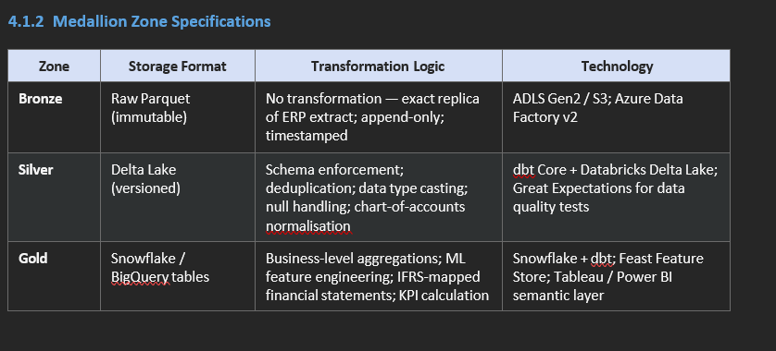

4.2 AFUM Matrix
The AFUM Matrix maps financial use cases to machine learning algorithms.
Use Case | Algorithm
Forecasting | LightGBM
Fraud Detection | Isolation Forest
Classification | FinBERT
Reporting | LLM

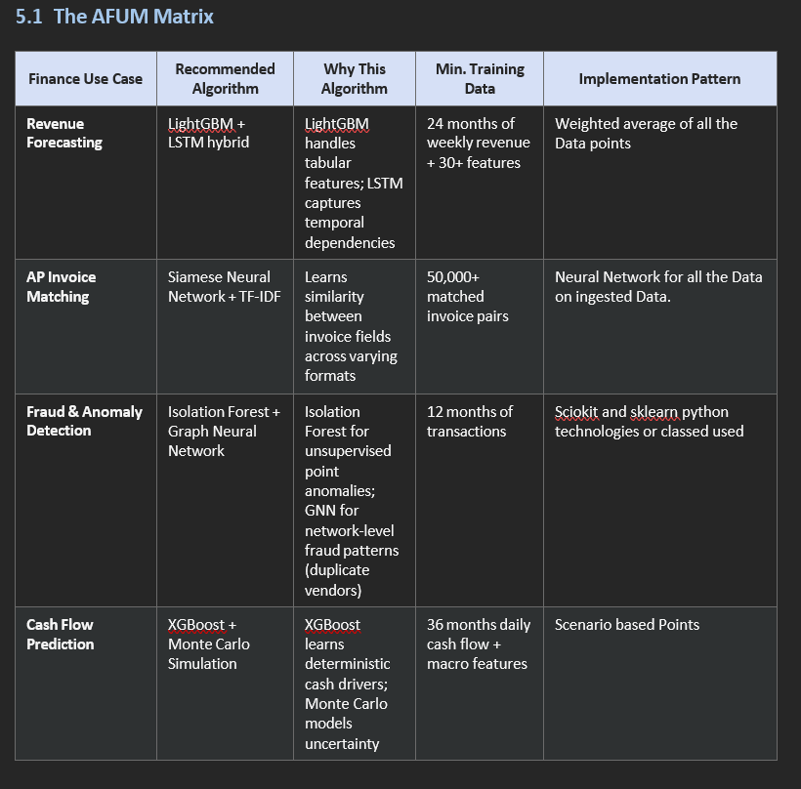

4.3 FinOps-CD Blueprint
This defines the DevOps architecture for deploying AI systems.
- CI/CD pipelines
- Docker containerization
- Kubernetes orchestration
- Automated monitoring

Code → Build → Test → Deploy → Monitor

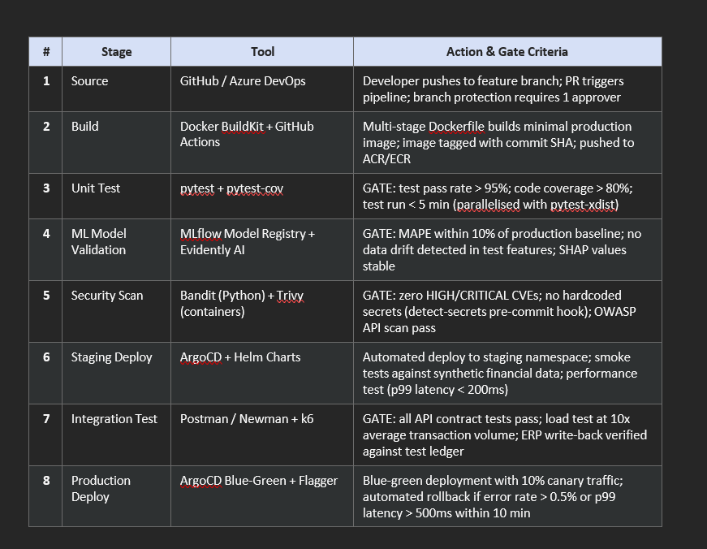

4.4 RT-FDE Pipeline
The RT-FDE pipeline processes financial data in real-time and batch modes.
- Real-time streaming using Kafka
- Batch processing using Spark
- Data transformation using dbt

ERP → Kafka → Data Lake → ML → Dashboard



5. Major Findings / Results
5.1 Key Outcomes
- Improved efficiency in financial operations
- Real-time fraud detection capabilities
- Enhanced forecasting accuracy
- Reduced manual workload

Before AIFT-MS → After AIFT-MS
Manual Work Automated Workflows
Delayed Reports Real-Time Insights
Errors High Accuracy
No AI AI-driven Decisions

3. KPI Improvement

Metric | Before | After
Processing Time | High | Low
Errors | High | Reduced
Decision Speed | Slow | Fast

6. Conclusion and Future Scope

6.1 Conclusion
The AIFT-MS framework provides a structured approach for integrating AI into financial operations. It enables organizations to improve efficiency, accuracy, and decision-making.

6.2 Future Scope
- Real-world implementation of the framework
- Extension to smaller enterprises
- Integration of advanced Generative AI tools

References

Barney, J. B. (1991). Firm resources and sustained competitive advantage. Journal of Management, 17(1), 99–120.

Cao, L. (2022). AI in finance: Challenges, techniques, and opportunities. ACM Computing Surveys, 55(3), 1–38.

Davis, F. D. (1989). Perceived usefulness, perceived ease of use, and user acceptance of information technology. MIS Quarterly, 13(3), 319–340.

Ge, M., & Helfert, M. (2007). A review of information quality research. In Proceedings of the 12th International Conference on Information Quality (ICIQ).

Goldratt, E. M., & Cox, J. (1984). The goal: A process of ongoing improvement. North River Press.

Gregor, S. (2006). The nature of theory in information systems. MIS Quarterly, 30(3), 611–642.

ISO/IEC. (2023). ISO/IEC 42001:2023 — Information technology: Artificial intelligence: Management system. International Organization for Standardization.

Kleppmann, M. (2017). Designing data-intensive applications. O’Reilly Media.
Lundberg, S. M., & Lee, S. I. (2017). A unified approach to interpreting model predictions. In Advances in Neural Information Processing Systems, 30.

McKinsey Global Institute. (2023). The economic potential of generative AI: The next productivity frontier. McKinsey & Company.
‘
Ng, A. (2018). AI transformation playbook: How to lead your company into the AI era. Landing AI.

Reis, J., Amorim, M., Melao, N., & Matos, P. (2018). Digital transformation: A literature review and guidelines for future research. Advances in Intelligent Systems and Computing, 745, 411–421.

Tornatzky, L. G., & Fleischer, M. (1990). The processes of technological innovation. Lexington Books.

Walls, J. G., Widmeyer, G. R., & El Sawy, O. A. (1992). Building an information system design theory for vigilant EIS. Information Systems Research, 3(1), 36–59.
Westerman, G., Bonnet, D., & McAfee, A. (2014). Leading digital: Turning technology into business transformation. Harvard Business Review Press.

Zahedi, F., & Song, J. (2008). Dynamics of trust revision: Using health infomediaries. Journal of Management Information Systems, 24(4), 225–248.

